# Wedding Website

## Where and When

The ceremony will be held on **Saturday, July 9, 2016** at the [**Armour House, 1500 W Kennedy Road, Lake Forest, IL**](http://ohai.kimawedding.com/) . The ceremony will start at **5:00** in the evening.

A celebration with a cocktail hour, dinner, drinks and dancing will follow at the **Armour House**.

## Hotel

There is a block of rooms reserved for guests at the Hilton Garden Inn under "Pepoon-Mikhelson" wedding.

[lakeforestmettawa.stay.hgi.com](http://lakeforestmettawa.stay.hgi.com/)

1-877-STAY-HGI

[1-847-735-8374](tel:1-847-735-8374)

The hotel is 5 minutes away from Armour House.

26225 N Riverwoods Blvd

Mettawa, IL 60045

The hotel has complimentary parking, pool, whirlpool, restaurant, free wifi and a workout room.

There will be a complimentary shuttle taking guests from the hotel to the Armour House and back to the hotel in the evening. More details about the shuttle will be provided as the date comes closer.

http://hiltongardeninn.hilton.com/en/gi/groups/personalized/O/ORDLFGI-PEPMIK-20160709/index.jhtml?WT.mc_id=POG

## Bridesmaids

* Jackie Pepoon- Maid of Honor
  + Sister of the Bride
* Miriam Mikhelson
  + Sister of the Groom
* Evelyn Czmiel Roth
  + Friend of the couple
* Joanna Czmiel
  + Friend of the couple
* Mary Kotova
  + Friend of the couple
* Theodora Liakos
  + Friend of the couple
* Charu Dhanda
  + Friend of the couple

## Groomsmen

* Ilya Mikhelson, Best Man
  + Brother of the Groom
* Tim Selimkhanov
  + Cousin of the Groom
* John Selimkhanov
  + Cousin of the Groom
* Eugene Backiev
  + Friend of the couple
* Eugene Frankfurt
  + Friend of the couple
* Mike Ushman
  + Friend of the couple

## The Love Story

## Dima and Kimmi attended Glenbrook North High School. They shared some friends but didn't hang out much and didn't suspect what the future held for them. Kimmi taught Dima’s sister in Ice Skating and Dance camp. They both went on to study at University of Illinois Champaign and occasionally ran into one another. After college, Kimmi flew off to Germany and Dima settled down in Chicago. Two years later, when Kimmi moved back to Chicago, their friendship was rekindled by a shared love of electronic music. They began spending time together on the weekends, joined a volleyball league, began dating in April 2012, and have been inseparable since.

## The Big Proposal

On Kimmi’s birthday, the same day she graduated from her MBA program, Dima surprised her with a very special present - a trip to Miami!! Upon their arrival Dima started showering Kimmi with roses and chocolate. Despite the forecast, the weather turned out perfect. The sun was shining and the birds were singing a joyous tune. Kimmi and Dima decided to go for a bike ride and he knew the moment was ripening. But where to hide the ring? Thinking quickly, he waited for Kimmi to turn her back for a second and tied the ring inside his basketball shorts. They rented bikes and rode to the beautiful Vizcaya Gardens, perched atop Biscayne Bay. They toured the grounds until they happened upon a secret secluded spot. And as they say, the rest is history.

## The Gallery

But why bore you with words? We’ll allow the pictures speak for themselves.

## Ceremony and Reception

The Armour House

1500 W Kennedy Road

Lake Forest, IL 60045

https://armourhousecatering.sodexomyway.com/?

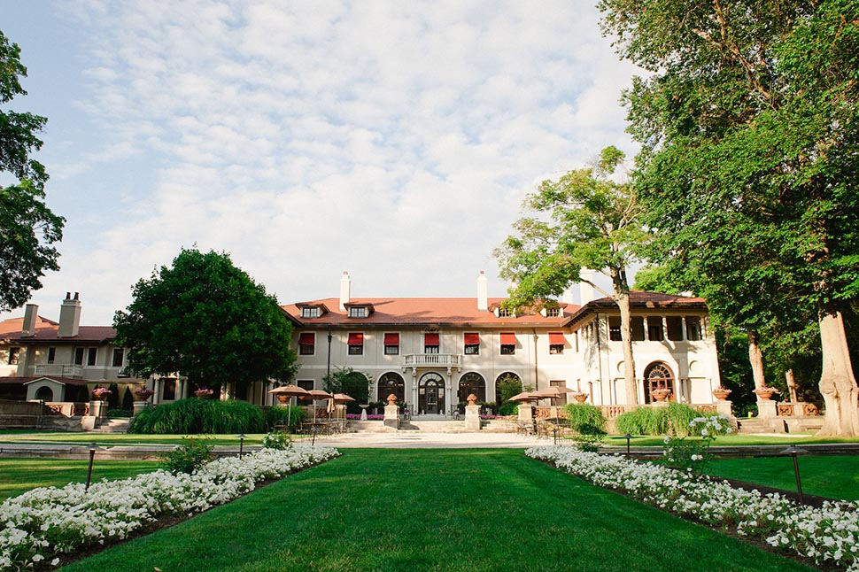

**Directions to the Armour House**

From Tri State 94 exit heading east on IL 60-East/Townline Road (.9 mile).

Turn left onto Academy Drive and continue the drive along the lake and wooded area until the very end of the road.

**MAP?**

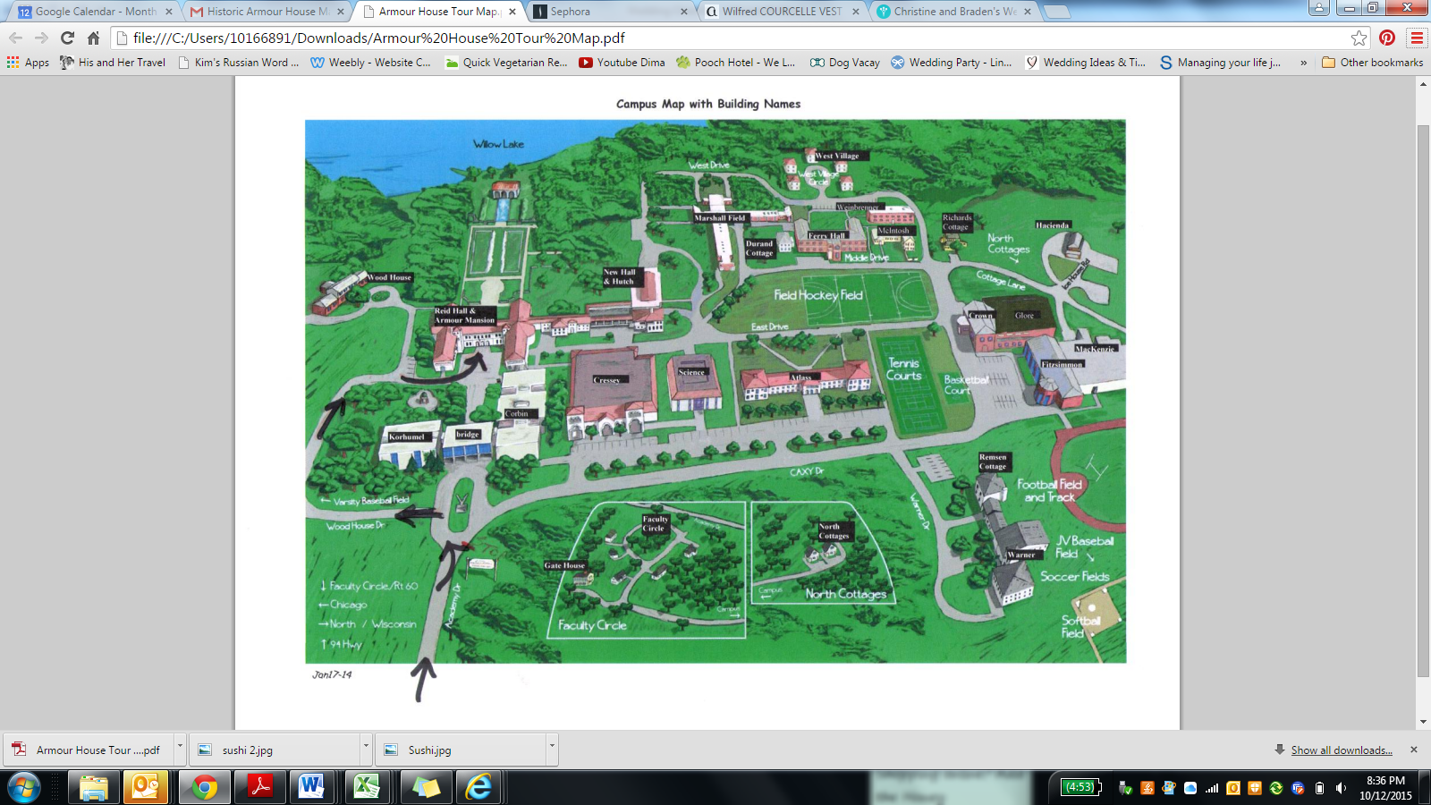

**Parking Information?**

## Wedding Registry

## Guest Information

We have reserved a block of rooms at XXX hotel.

At XXX pm, there will be a free shuttle taking guests to Armour House

In the evening, there will be a free shuttle at XXX pm and XXX pm back to the hotel.

Lake Forest Taxi can also be reached at 847-660-4554.

Please don’t hesitate to contact us with any questions you have!

Dmitriy Mikhelson: 847-962-1110

Kimmi Pepoon: 224-628-0709, kim.pepoon@gmail.com

## Honeymoon

